Project Design Phase-II

**Data Flow Diagram**

|  |  |
| --- | --- |
| Date | 21 October 2022 |
| Team ID | PNT2022TMID07522 |
| Project Name | Smart farmer – IOT Enabled Smart Farming  Application |
| Maximum Marks | 4 Marks |

**Data Flow Diagrams:**

A Data Flow Diagram (DFD) is a traditional visual representation of the information flows within a system. A neat and clear DFD can depict the right amount of the system requirement graphically. It shows how data enters and leaves the system, what changes the information, and where data is stored.

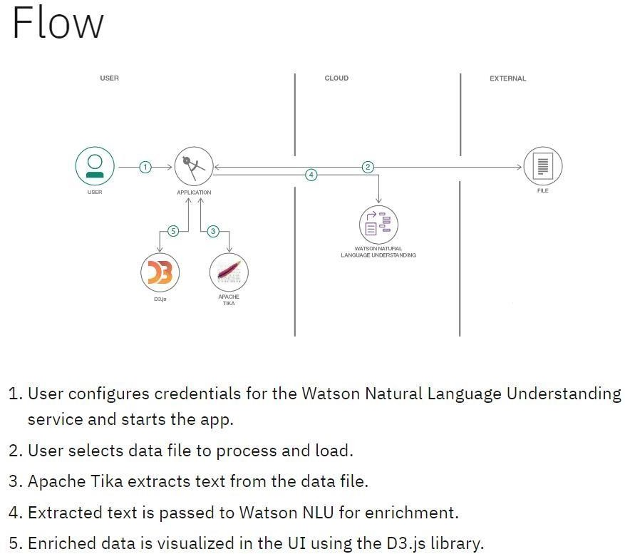

SMART FARMING BASED ON IOT

**Example:** [(Simplified)](https://developer.ibm.com/patterns/visualize-unstructured-text/) **User Stories**

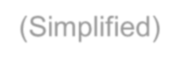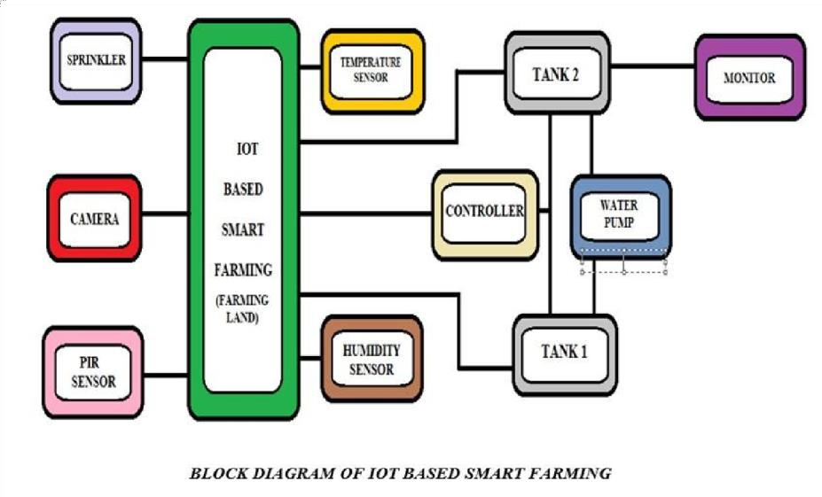

Use the below template to list all the user stories for the product.

|  |  |  |  |  |  |  |
| --- | --- | --- | --- | --- | --- | --- |
| **User Type** | **Functional Requirement (Epic)** | **User Story Number** | **User Story / Task** | **Acceptance criteria** | **Priority** | **Release** |
| Customer (Mobile user) | Registration | USN-1 | As a user I can user can register or use our application either by enrolment form. | I will receive otp in the mail, I should enter it into the second page of enrolment form. | High | Sprint-1 |
|  |  | USN-2 | As a user, I will receive confirmation email once I have registered for the application | I will log into my account the application | High | Sprint-1 |

|  |  |  |  |  |  |  |
| --- | --- | --- | --- | --- | --- | --- |
|  |  | USN-3 | As a user, I can register for the application through Facebook, Linked in, Go daddy application. | I can access my account in application either by Facebook Linked in ,Go daddy applications . | Medium | Sprint-2 |
|  |  | USN-4 | As a user I can use my account in case I forget I can access my account by asking help desk | I will chat with the technical support team , they will guide me how to access my account | High | Sprint-1 |
|  | [Login](https://developer.ibm.com/patterns/visualize-unstructured-text/) | [USN-5](https://developer.ibm.com/patterns/visualize-unstructured-text/) | [A](https://developer.ibm.com/patterns/visualize-unstructured-text/)s a user, I can log into the application by [e](https://developer.ibm.com/patterns/visualize-unstructured-text/)ntering user ID, password and otp sent to [y](https://developer.ibm.com/patterns/visualize-unstructured-text/)our mobile number or your mail id. | I can access my account after finishing login steps. | High | Sprint-1 |
|  | [Dashboard](https://developer.ibm.com/patterns/visualize-unstructured-text/) | [USN-6](https://developer.ibm.com/patterns/visualize-unstructured-text/) | [D](https://developer.ibm.com/patterns/visualize-unstructured-text/)ash board will be available so that you [c](https://developer.ibm.com/patterns/visualize-unstructured-text/)an monitor your daily activity | I can use the dashboard after login in with proper  id. | Medium | Sprint-2 |
| [Customer](https://developer.ibm.com/patterns/visualize-unstructured-text/) [(Web user)](https://developer.ibm.com/patterns/visualize-unstructured-text/) | [Website](https://developer.ibm.com/patterns/visualize-unstructured-text/) | [USN-1](https://developer.ibm.com/patterns/visualize-unstructured-text/) | [T](https://developer.ibm.com/patterns/visualize-unstructured-text/)he customer can analyse and know about [t](https://developer.ibm.com/patterns/visualize-unstructured-text/)he information of farming through our [w](https://developer.ibm.com/patterns/visualize-unstructured-text/)ebsite. | I can work through website for analyzing and maintaining. | High | Sprint-3 |
| [Customer Care](https://developer.ibm.com/patterns/visualize-unstructured-text/) [Executive](https://developer.ibm.com/patterns/visualize-unstructured-text/) | [Q/A](https://developer.ibm.com/patterns/visualize-unstructured-text/) | [USN-1](https://developer.ibm.com/patterns/visualize-unstructured-text/) | [If](https://developer.ibm.com/patterns/visualize-unstructured-text/) the customer has a any problem or any [d](https://developer.ibm.com/patterns/visualize-unstructured-text/)oubt can ask through the mentor with the [c](https://developer.ibm.com/patterns/visualize-unstructured-text/)hat box or toll free number that is customer [c](https://developer.ibm.com/patterns/visualize-unstructured-text/)are service. | I will follow through problems faced by the customer and solve as soon as possible. | High | Sprint-3 |
| [Administrator](https://developer.ibm.com/patterns/visualize-unstructured-text/) | [Administration](https://developer.ibm.com/patterns/visualize-unstructured-text/) | [USN-1](https://developer.ibm.com/patterns/visualize-unstructured-text/) | [T](https://developer.ibm.com/patterns/visualize-unstructured-text/)he progress and survey will be undergo by  the administration. | I will be double checking  everyone’s work. | High | Sprint-4 |